**Financial inclusion initiatives in the US banking system**

Financial inclusion initiatives in the US banking system aim to expand access to safe and affordable financial services for all individuals and households. These initiatives focus on increasing the number of people who have access to transaction accounts and other financial products and services.

**Initiatives and Programs**

**Banking Inclusion Initiative:** Wells Fargo's 10-year commitment to improve accessibility and affordability of banking services and funding for underserved communities and households, focusing on Black and African American, Hispanic, and Native American/Alaska Native families.

**Financial Inclusion Forum:** The Obama Administration's initiative to expand access to safe and affordable financial services, including low- and moderate-income households, through initiatives such as the Financial Inclusion Forum, the Financial Empowerment Innovation Fund, and participation in the G-20's Global Partnership for Financial Inclusion[3].

**Universal Financial Access 2020:** The World Bank Group's initiative to ensure that all adults have access to a transaction account by 2020, which concluded at the end of 2020[4].

**Progress and Challenges**

**Financial Inclusion Trends:** The share of families with transaction accounts has been on the rise since 1989, with 93.2% of families having such accounts as of 2013. However, the median value in these accounts has been flat since 1989, and there are still significant barriers to financial inclusion, including lack of financial capability and distrust of banks[3].

**Digital Financial Inclusion:** The COVID-19 pandemic has accelerated the adoption of digital payments in developing countries, but close to one-third of adults worldwide are still unbanked, with significant gender and income gaps.

**Payment Inclusion:** Initiatives to promote payment inclusion, such as expanding the supply of transaction accounts and boosting consumer demand, are ongoing, but assessing the effectiveness of these measures is challenging, and there are potential areas for future research.

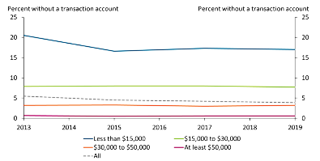

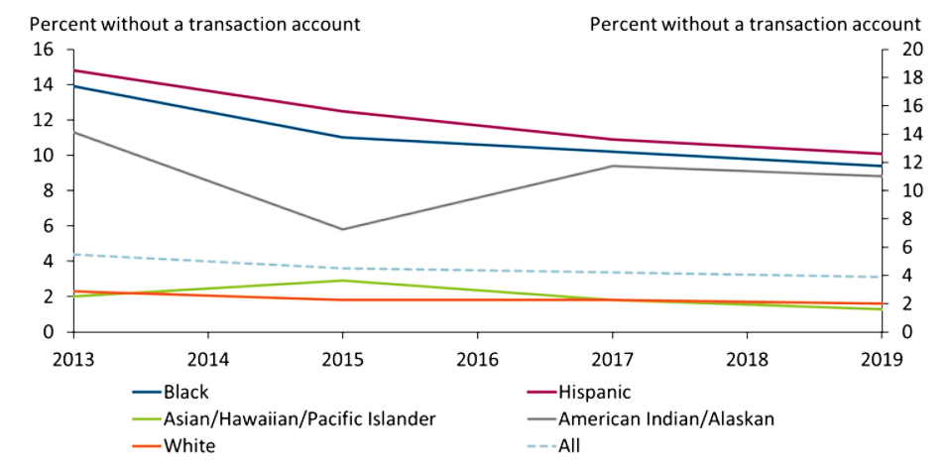

**Impact and Future Outlook**

**Financial Inclusion and Economic Development:** Financial inclusion is seen as an enabler for economic development, as it allows individuals and businesses to access financial services that facilitate day-to-day living, long-term goals, and unexpected emergencies.

**Future Directions:** The ongoing COVID-19 crisis has reinforced the need for increased digital financial inclusion, and there are ongoing efforts to develop national financial inclusion strategies that bring together diverse stakeholders to promote responsible and sustainable financial services.

**challenges faced by unbanked communities in the US**

**Minimum Balance Requirements:** Traditional banks require customers to maintain a minimum balance to avoid fees, which can be a significant barrier for low-income individuals and those starting out.

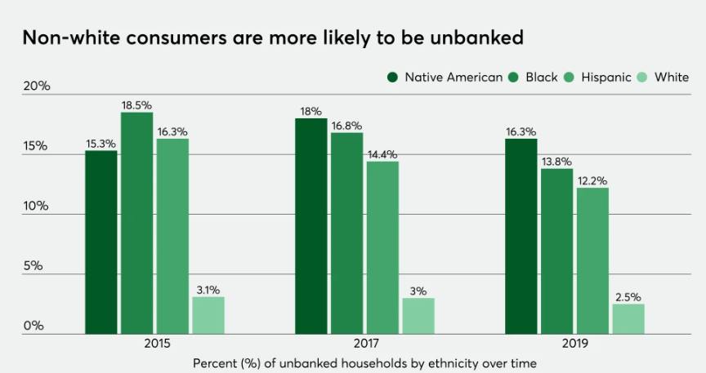

**No Credit History:** The traditional banking system fails to serve immigrants and young workers, who lack a credit history, making it difficult for them to establish credit and access financial services.

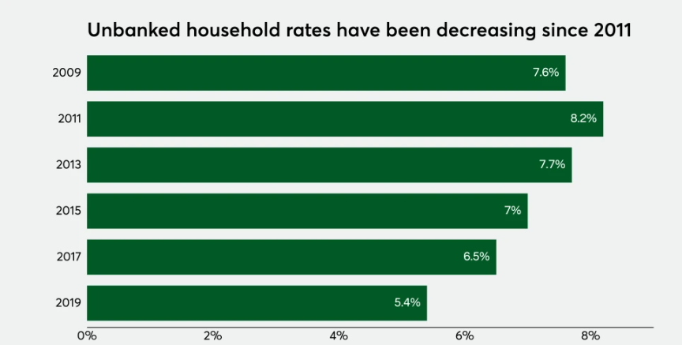

**Lack of Trust:** Many unbanked individuals distrust banks due to past experiences with redlining, predatory lending, or high fees, which can lead to a lack of trust in the financial system.

**Alternative Financial Services:** Unbanked individuals often rely on alternative financial services like payday lenders, pawn shops, and check-cashing services, which can be expensive and provide limited financial benefits.

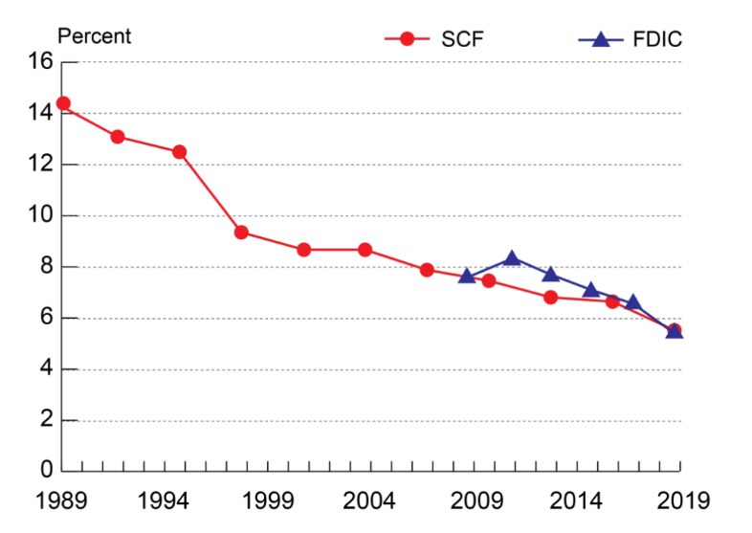

**Digital Payments:** The shift to digital payments during the COVID-19 pandemic has further exacerbated the challenges faced by unbanked communities, who may not have access to digital financial services or may be more vulnerable to financial exclusion.

**Income Volatility:** Low-income individuals, particularly those in African American communities, often face income volatility, making it difficult to maintain a minimum balance and avoid fees in traditional banking systems.

**Limited Access to Documentation:** Many unbanked individuals lack the necessary documentation, such as a driver's license or social security number, required by traditional banks to open an account.

**Geographic Barriers:** Limited access to financial institutions and services in predominantly African American neighborhoods can further exacerbate financial exclusion.